FACULTY EVALUATION
Programme Name: Sisters’ Blended Value Program (Sbvp)Social Entrepreneurship Development Program (SEDP) Advance Module 3 Zambia (26th January 2026 - 30th January 2026)
Session: Establishing Social Impact Measuring /Social Impact
Faculty Name: Dr. William Karani Murithi
No. of Respondents: 12
No. of Participants: 12
Evaluation Parameter | (%) Individual Score | (%) Programme Average
Punctuality (Commencement and Completion of Sessions) | 95 | 95
How well do you understand the core concepts presented? | 87 | 91
Rate your confidence in applying the new skills learnt | 92 | 92
Degree of Faculty preparedness for the sessions | 93 | 95
Content and methodology of the program | 95 | 96
Quality of class and group discussions | 87 | 95
The information presented in the course is relevant to my work (ministry) | 95 | 92
Average scores | 92 | 94

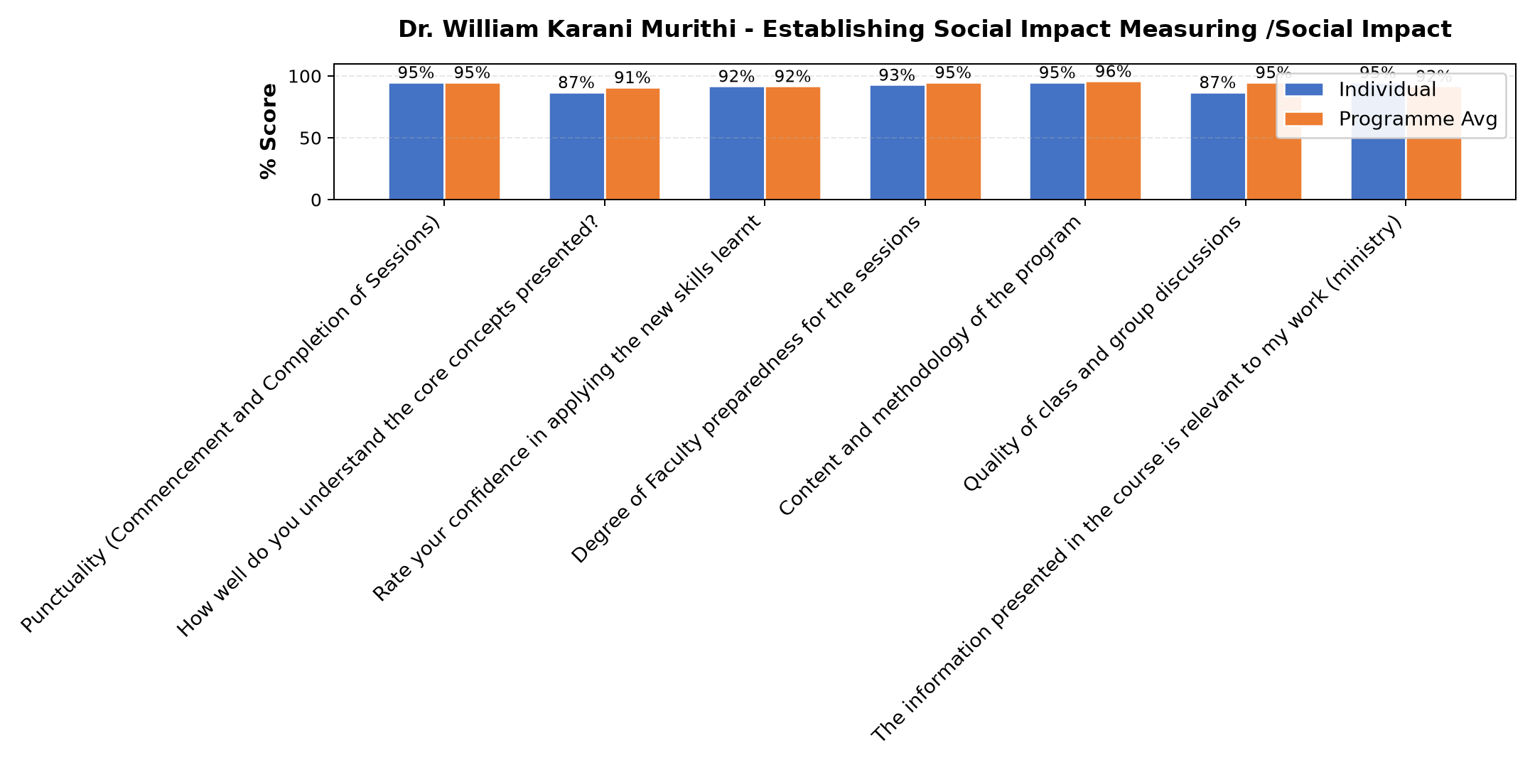

Comments & Feedback
- • Well done
- • This was a very practical topic. Where I could have been left behind, I was carried along. Wonderful
- • To see what i leant to pu into action and have friuts,in my bussines.
- • Very effective to my project, thanks so much
- • Mr. William his a good presenter
- • Thank you for today work. I understood some of the concept, some area he was a little bite too fast to fully understand. Otherwise he is great. If possible kindly send the notes so that we write what we missed out. Thanks a lot.
- • As for outing I am so impressed with the work the SJ are doing. It really requires energy and passion. Father has taught me how passion and determination work together. I have learnt how organic food is grown as how many of the products they produce and ends at our tables without knowing. I have learnt how organic food is healthy and what different mixtures they do to come up with the manure to fertilize the soil. Thank a lot it was a beautiful experience as well my first to reach Kasia.
- • Was very insightful
SUBMITTED THROUGH:
SBS Evaluation Automation System

